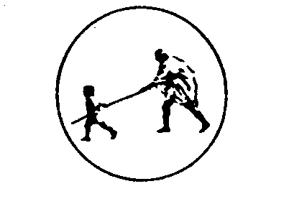
M.G.M.’S College of Engineering, Nanded.
Department of Computer Science & Engineering
Assignment - III
Class: T.E.(CSE) – I & II Subject: TOC

- Explain Model of PDA along with its methods of acceptance.
- Explain Closure Properties of Context Free Languages with examples.
- Construct a PDA accepting the following language by final state:
    - L = {w Є {a,b}* | N_{a}(w) ≠ N_{b}(w) }

    - L = {w Є {a,b}* | N_{a}(w) < N_{b}(w) }
where, N_{a}(w) & N_{b}(w) are number of a’s and b’s in w respectively.

- Construct a PDA accepting the following language by null store:
    - L = { a^{n} b^{(n+m)} a^{m} | n, m ≥ 1}

  - L = { a^{n} b^{m} c^{2(n+m)} | n, m ≥ 1}

  - L = { 0^{n} 1^{m} | n, m ≥ 1 & n ≥ m}

- Construct a PDA equivalent to the following CFG:

  - S→0 S 1| A , A→1 A 0 | S | ^

  - S→A B | D , A→a | ^ , B→b ,

- Construct a CFG which accepts the language of following PDA:

- M = ( { q₀, q₁} , {a, b}, {a, Z₀},   q₀, Z₀, φ ).
- Where, :

          -  ( q₀,a, Z₀) = ( q₀, a Z₀ )
          -   ( q₀, a, a) = ( q₀, a a )
          -   ( q₀,b, a) = ( q₁, a )
          -   ( q₁,b, a) = ( q₁, a)
          -  ( q₁,a, a) = ( q₁, ☹ )
          -   ( q₁, ☹, Z₀) = ( q₁, ☹ )

- Explain application of finite automata for text search with an example.

- Design a DFA that recognizes the occurrences of following set of keywords:
          - “bat” and “cat”. Assume = {a, b, c, d … z}.
          - “ab”,”bc” and “ca”. Assume = {a, b, c}.

  - Explain application of regular expressions for lexical analysis.
  - Describe application of regular expressions for finding patterns in text.

- Give a regular expression to describe phone numbers in all various forms.
- Explain application of context-free grammar in parsing.
- Explain application of context-free grammar in Document Type Definitions (DTD) in XML.
- Define Turing machine (TM). Explain model of Turing machine with example.
- Design Turing machine that accepts the following languages:
  - The set of all strings with equal number of 0’s and 1’s.
  - L = { w w^{R} | w is any string of 0’s and 1’s }
  - L = { 1^{n} 2^{n} 3^{n} | n ≥ 0 }

- Explain the following:
        - Multi stack Turing machine
        - Multi tape Turing machine
        - Universal Turing machine

- Describe the following:
        - Recursively enumerable language
        - Recursive language
        - Decidable language
        - Un-decidable language

          - Subject In-charge
- Md. Aijaz Ahmed -
- B.S. Kapre -

